Kyle Evangelisto

Professor Weissman

Lab06-B

07 October 2020

First Run:

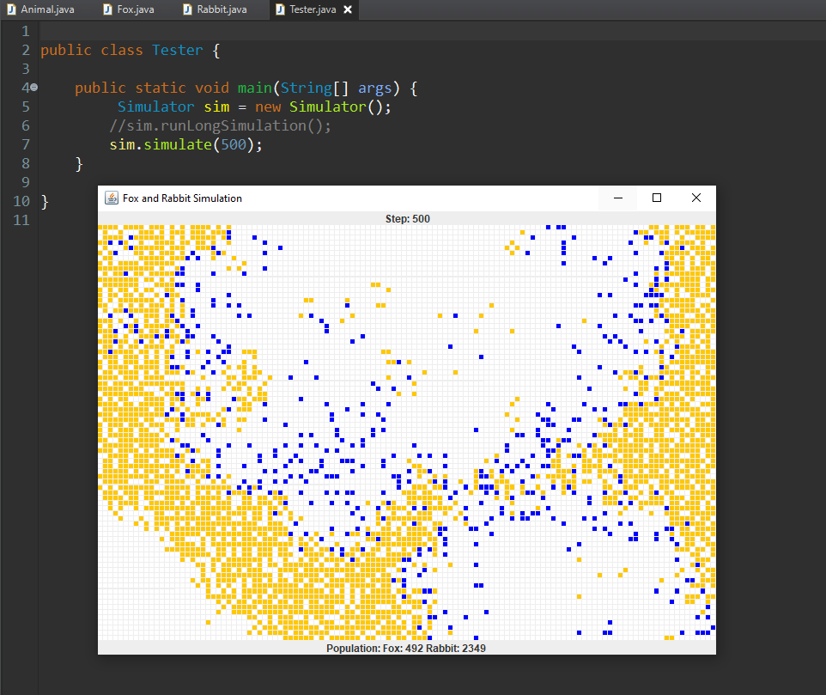

Second Run:



I did get the same values in both test runs.

You can not move the breed() method into the animal super class. I mean you could, but it uses too many different fields such as rand, BREEDING_PROBABILITY and MAX_LITTER_SIZE.

I got the same values after changing the Animal superclass and removing duplicate code.

